# Post Intercepting

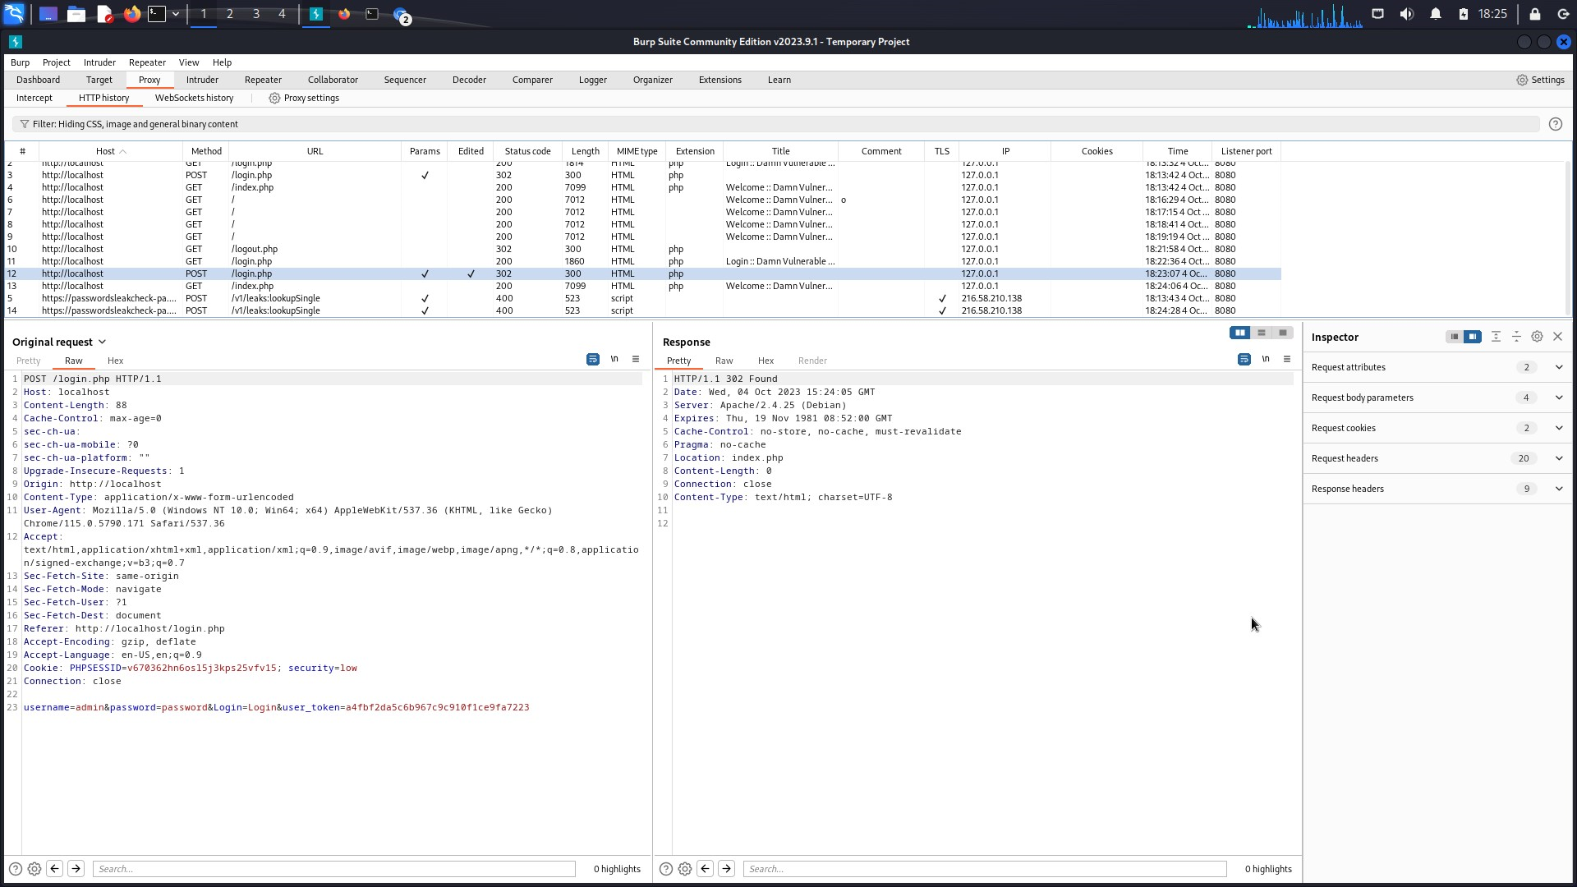

# Get Intercepting

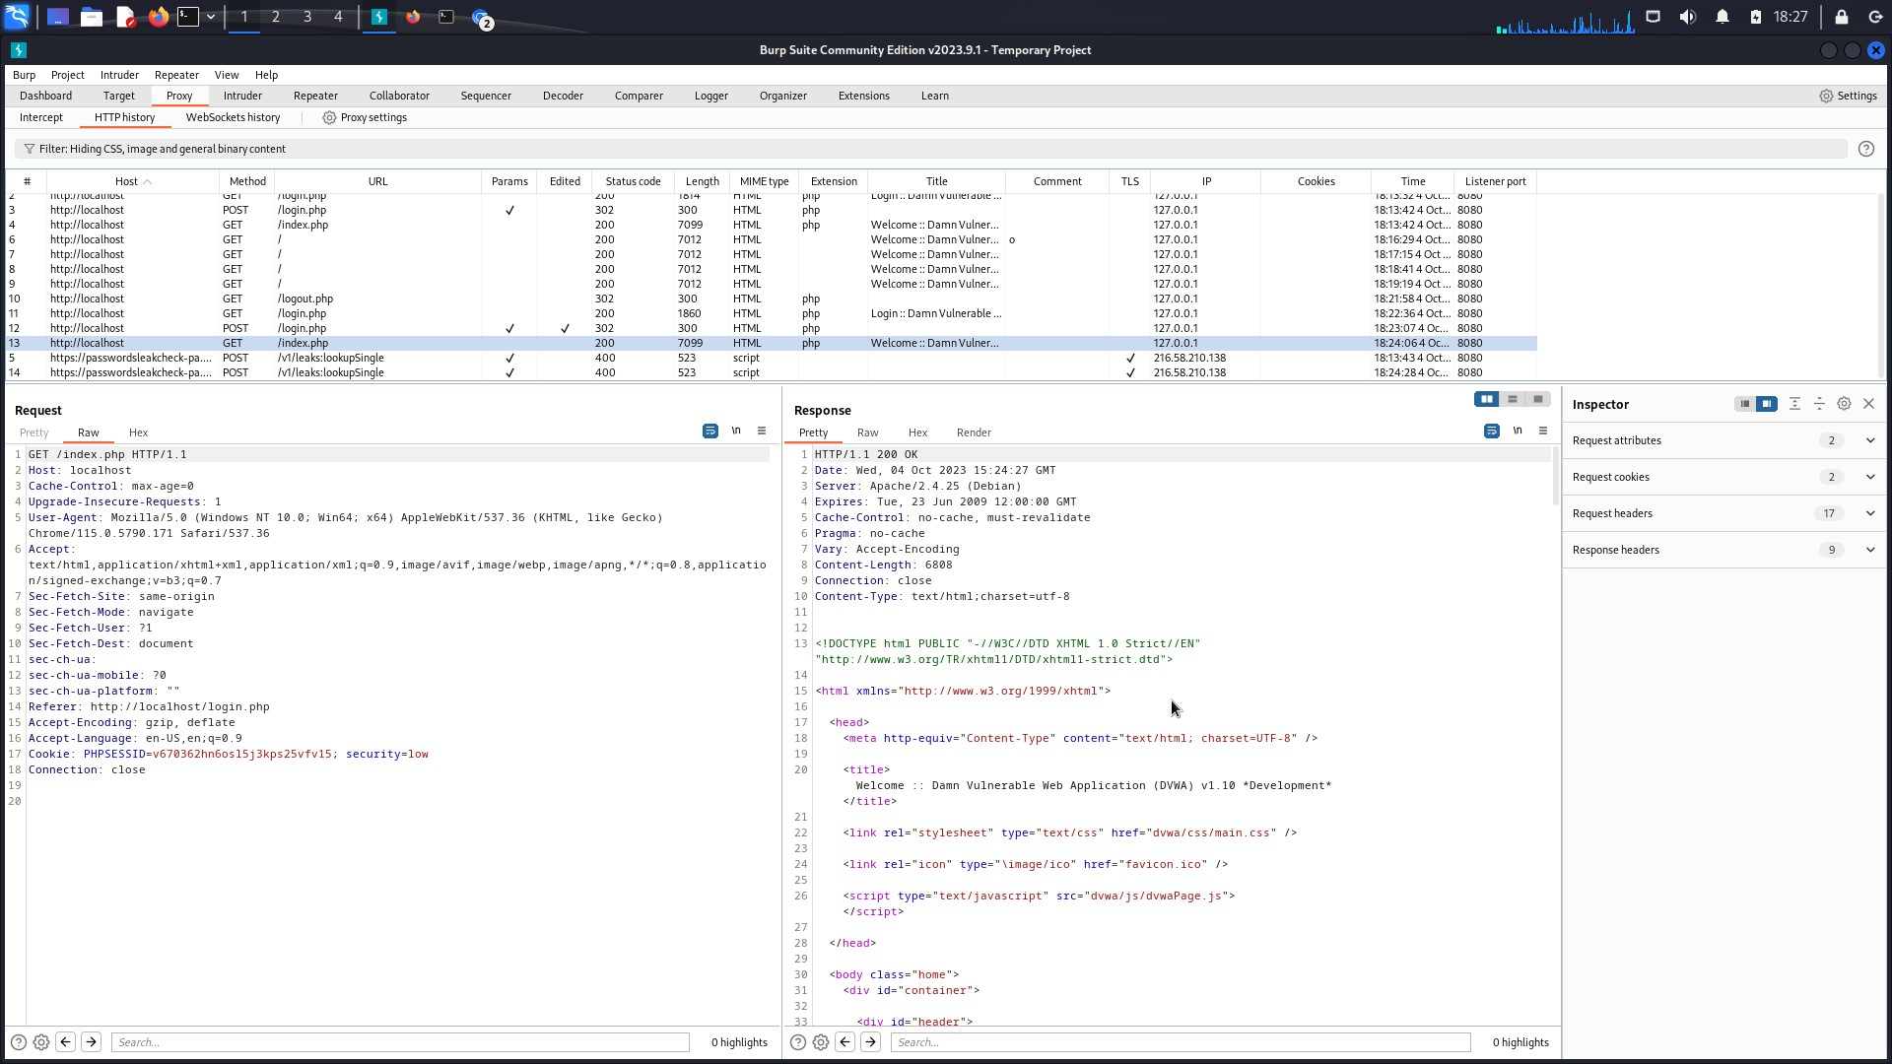

# ****Edited POST request in raw format****

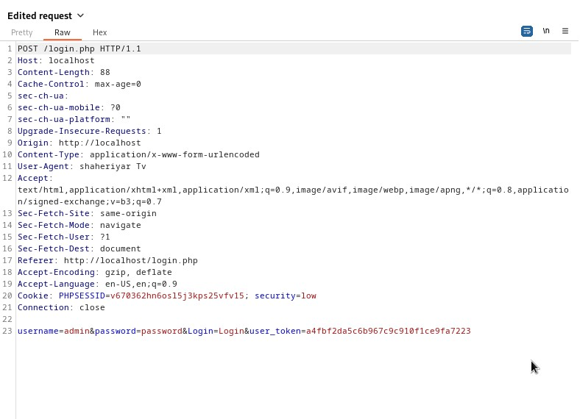

**Sub Task 2**

**Explanation:**

As the DVWA session number is increasing which leads us to know that a new cookie is generated

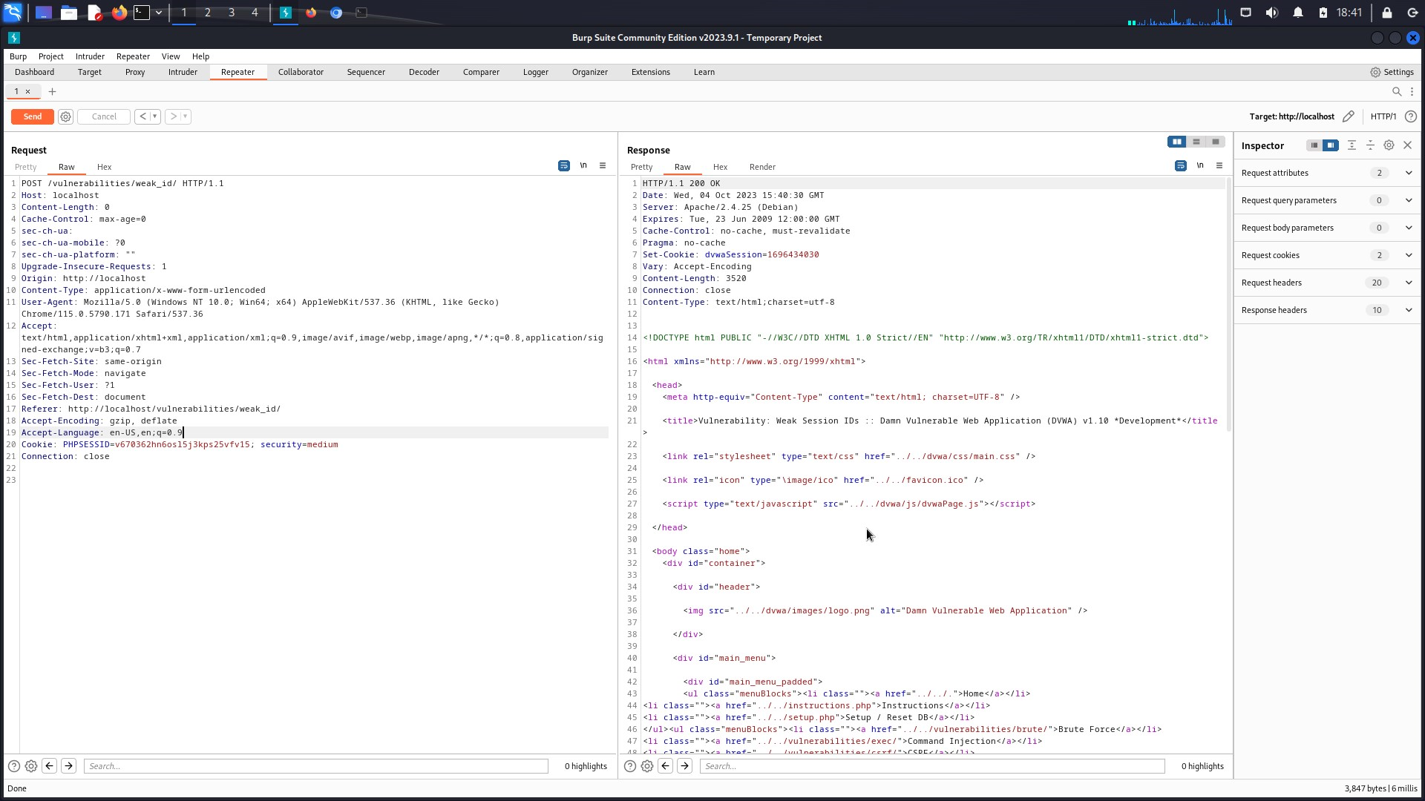

**Sub Task 3**

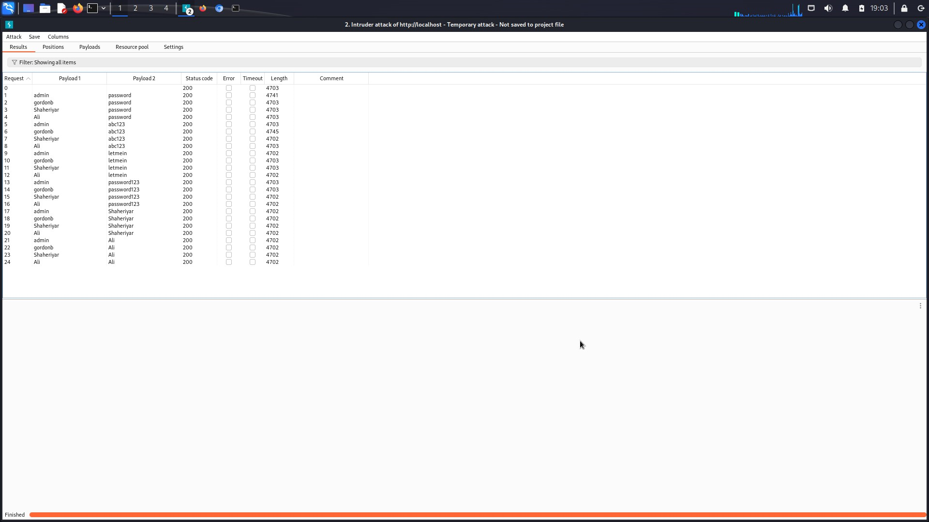

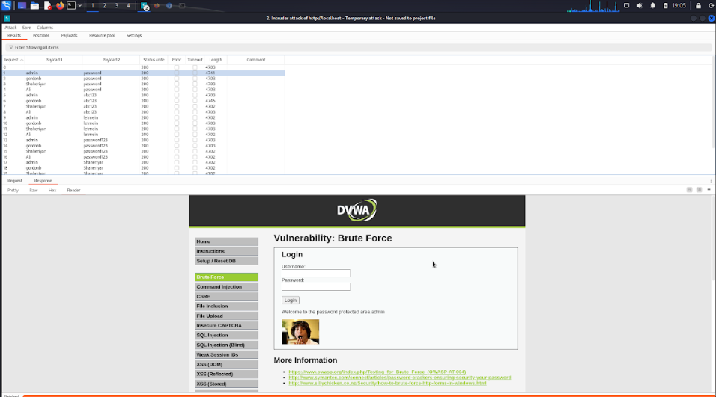

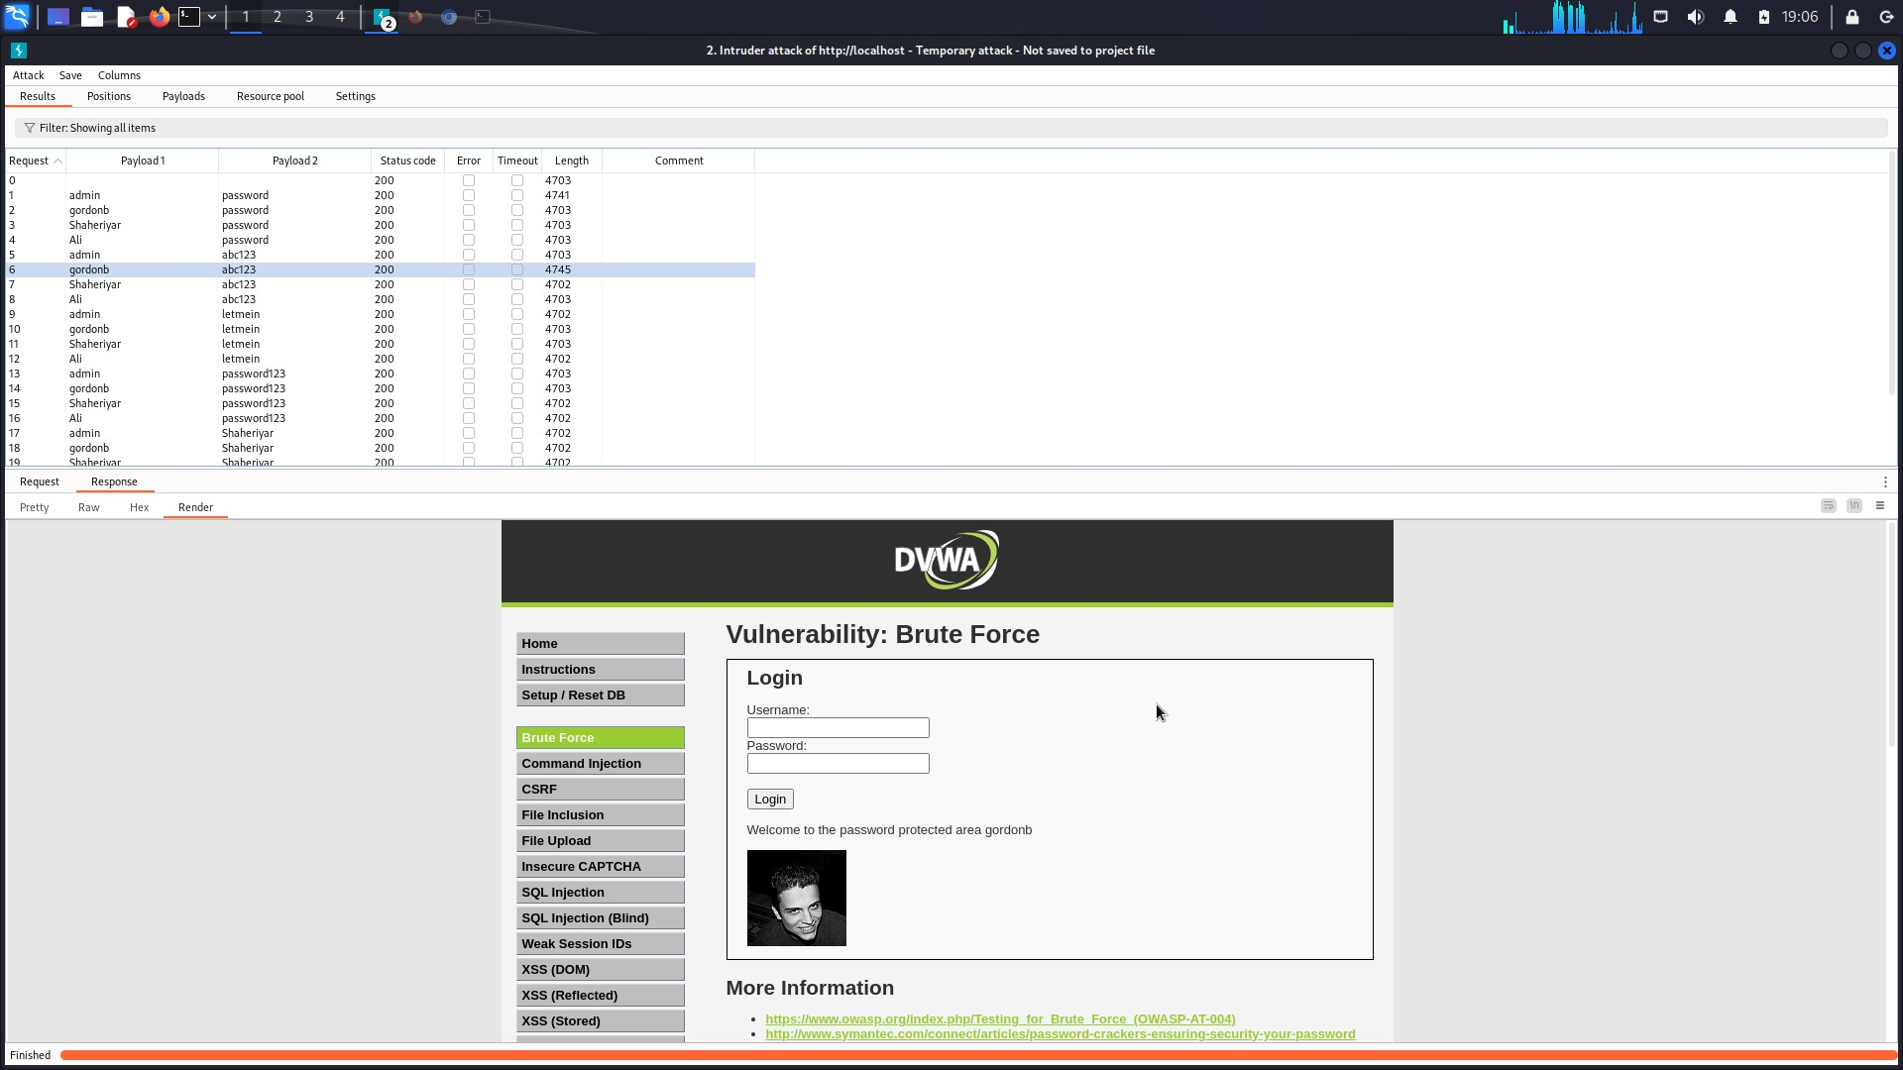

**Sub Task 4**

**Decoder:**

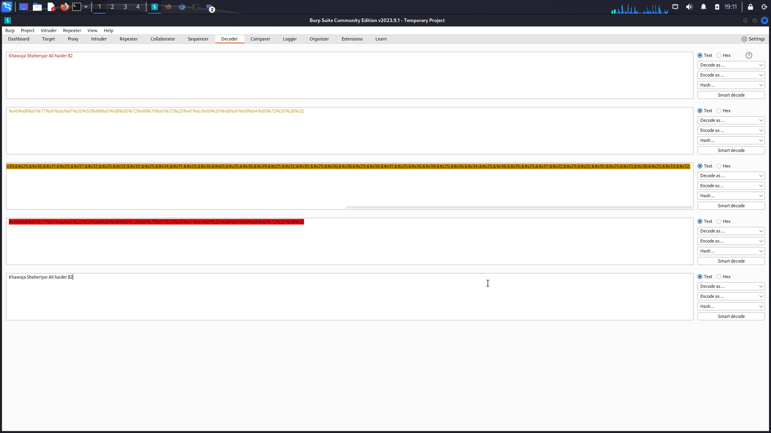

**Sub Task 5**

**Successful Crack:**

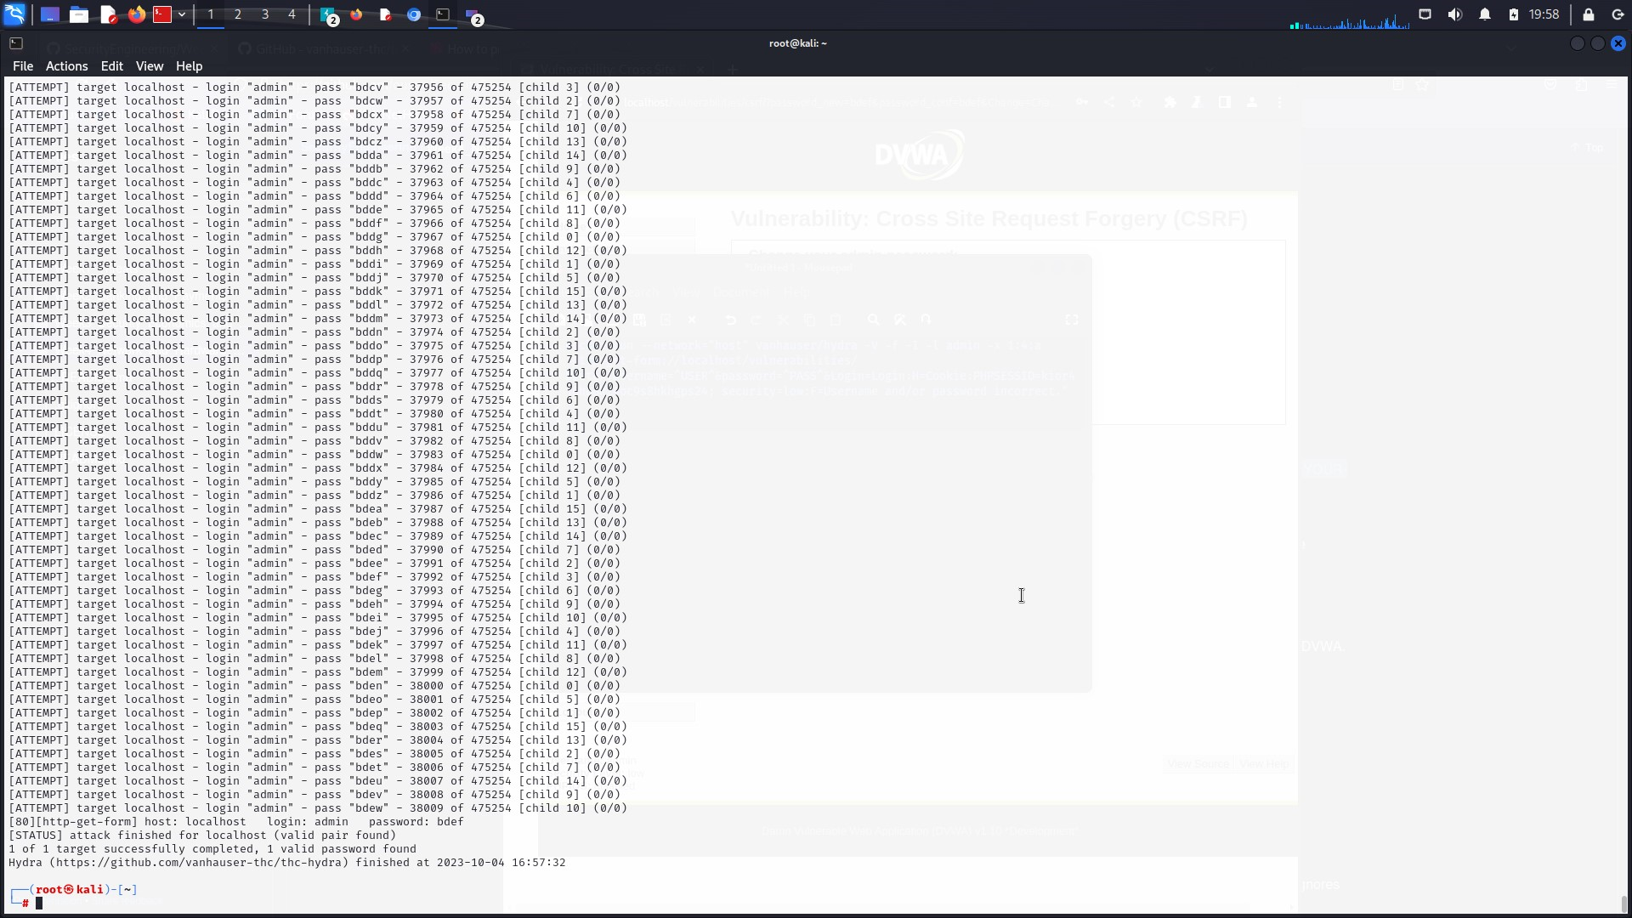

**Initiation:**

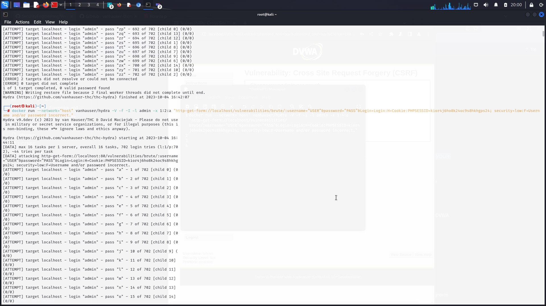

The brute force processing took 14 minutes in total to crack the password.

# Full Hydra Command

